

**Procurement Process**

**Version History:**

|  |  |  |  |  |  |
| --- | --- | --- | --- | --- | --- |
| **Ver. No.** | **Date** | **Amendments made** | **Author** | **Reviewed By** | **Approved By** |
| 0.1 | 15th May, 2008 | Initial Draft |  |  |  |
| 1.0 | 05th June, 2008 | Initial Release  & Added the email in the section beside purchase order | Gaurav Rakheja | Mr. Sudhir Saxena | Mr. Sudhir Saxena |
| 2.0 | 16th Nov, 2009 | Modified sec 6 | Abhishek Rautela | Mr. Sudhir Saxena | Mr. Sudhir Saxena |
| 2.1 | 1st May, 2010 | Formatting changes & Reviewed | Neha Gupta | Abhishek Rautela | Mr. Sudhir Saxena |
| 3.0 | 5th January 2011 | Update Task and Purchase section | Neha Gupta | Abhishek Rautela | Mr. Sudhir Saxena |
| 3.1 | 17th January 2012 | Update section 5 & 6 | Ajeet | Saket | GM Dua |
| 3.2 | 22nd January 2012 | Update section 6.1.1 | Ajeet | Saket | GM Dua |
| 3.3 | 16th May 2016 | Update section 6.1 for Vendor Evaluation | Rahul | SEPG Team | Ajay Kumar Zalpuri |
| 3.4 | 5th Feb 2018 | Update section 6.1.1 | Ajeet | Saket | Ajay Kumar Zalpuri |
| 4.0 | 4th March 2019 | Merge 6.1 and 7 section. Introduce new section for Software License Purchase and Procurement process flow. Update in section 1 & 2 and introduce new section 3 for procurement policy. Rearrange sections | Rahul | Saket Madan | Manish Sehgal |

Table of Content

1. Purpose 4

2. Scope 4

3. Policy 4

4. Entry Criteria 4

5. Input 4

6. Responsibility 4

7. Software License Purchase and Control 5

7.1. Software License Pricing 5

7.2. Initial Maintenance Requirements and Pricing 5

7.3. New Versions 6

7.4. Future Maintenance Requirement and Pricing 6

7.5. Reviewing Existing and New Software Requirement 6

8. IT Procurement Process Workflow 7

8.1. Source Options 7

8.2. Making Purchase 7

8.3. Purchase Status Update 8

8.4. Tracking of Purchases 8

8.5. Vendor development and performance evaluation 9

9. Output 9

10. Validation 9

11. Exit Criteria 9

12. Reference documents 10

13. Glossary 10

# Purpose

The Purchase process covers purchases for organization. Purchase planning is carried out for smooth running of the procurement activities. The procurement process covers the acquisition activities related to hardware, software, licenses and day to day IT purchases. However, the day to day purchases may slightly differ from the defined process after approval from the senior management

This process defines the modalities of the delivery of materials and services by vendors, evaluation of supplier processes, acceptance or rejection of the delivered materials and services, and finally the certification of payment issued to accounts department.

However, if the vendor supplies physical items for a project then such items received, will undergo receipt and inspection process. These physical items will be marked to identify that these are vendor-supplied items.

# Scope

Procurement covers the process of acquiring products and services (including Hardware/Software/Licenses) from third parties. It ranges from the initial concept and definition of a business need through to the end of the useful life of a purchased asset or service contract.

# Policy

NST observes the highest standards of integrity when dealing with all matters concerning the procurement of goods and services. NST must:

* Be fair, efficient, transparent, and courteous
* Achieve the highest professional standards in the procurement and management of contracts if any
* Respond promptly, courteously and efficiently to suggestions and enquiries
* Respect the confidentiality of information relating to a procurement or contract and never use the information for personal gain.

# Entry Criteria

* When the organization decides to acquire materials/Software License/Services.
* Purchase Requests raised by Project Manager / Solution Head / IT Manager

# Input

* Project’s / Organization’s requirements

# Responsibility

|  |  |
| --- | --- |
| Position | Responsibility |
| Resource | * Raised a request |
| Manager | * Review and approved the request |
| Solution Head | * Review the request * Final Approval for the purchase as per requirements raised by user |
| IT Manager | * Review the purchase requirements as per stock availability * Selection of vendor by team * Asking for final approval for purchase from IT purchase Manager * After approval ask IT team members to raise Purchase Order |
| IT Purchase Manager | * Final approval for request to purchase |
| IT Team Members | * Purchase order raised |
| IT Manger/  IT Team members | * Purchase item received * Inspection check * Asset list updated * Issue asset to resource |

# Software License Purchase and Control

Software procurement is an activity that licenses the rights to use software as well as providing ongoing rights for the continuous use of the software. This may include software licenses, maintenance & support services and professional services like upgrades required for old license, new version or new software for implementation/development.

Typically, there are three types of contracts that need to be considered when optimizing software license. These contracts are software licenses, maintenance & support services, and professional services often related to project work (e.g. implementation services). Main software contract types are listed below.

## Software License Pricing

The price of the license is not typically based on the software development costs. It’s often influenced by the market conditions at the time of purchase. There are several licensing types and pricing / deployment models offered by software vendors. The type of license used (e.g. user/volume/access/enterprise/network) is not only important for setting the initial license cost but may also impact your total license cost over the lifecycle of the product, especially if there is a change in the volumes/requirements.

## Initial Maintenance Requirements and Pricing

IT team will start negotiating discounts on maintenance that’s often more difficult than on licenses but will be worth the effort, as the recurring maintenance fees will often cumulate to higher fees than initial license costs. Generally, the goal should be to negotiate a discount on a license fee and then apply ‘fit for purpose’ maintenance services against the discounted license fee. The warranty period that the licensor provides can have a significant impact on the overall maintenance fees. The sooner the warranty period ends, the sooner the maintenance fee commences. These can then be reviewed with the project technical team to ensure that the requirements are critical, and the service performance results (in case of an existing software) needed for the negotiation process

## New Versions

Software vendors will agree to provide support for older versions. It is important to agree on the number of versions that the vendor supports and that any potential price increases that may occur when remaining on an older version are capped at a reasonable level. Ideally the contract should also cover reduced support situations and reduced maintenance fees when new versions or releases are no longer provided.

## Future Maintenance Requirement and Pricing

IT team will check vendors that offer to protect the discounted license price for future maintenance renewals, whereas vendors use the current license price as a baseline. Keep in mind though, that typically maintenance and support fees cover only the standard software and any customizations and integration may attract additional maintenance and support fees.

## Reviewing Existing and New Software Requirement

IT team will look for upcoming existing requirements for addressing number of software requirements before renewing. Relevant stakeholders of NST can be involved in planning and development of these requirements, to optimize the cost. IT team will review of software license and maintenance contracts for licenses that are obsolete, or it has not been able to take advantage of upgrades. Review and re-specification of support requirements, including removal of unnecessary services, is often required to ensure appropriate support levels and optimized maintenance scope and pricing. Typically, there are spare licenses. Often this is a result of buying licenses without centrally managed processes and systems in place. NST software asset management processes and systems will support identification and cancellation / re-allocation of excess or idle / unused licenses and maintain assets inventory.

# IT Procurement Process Workflow

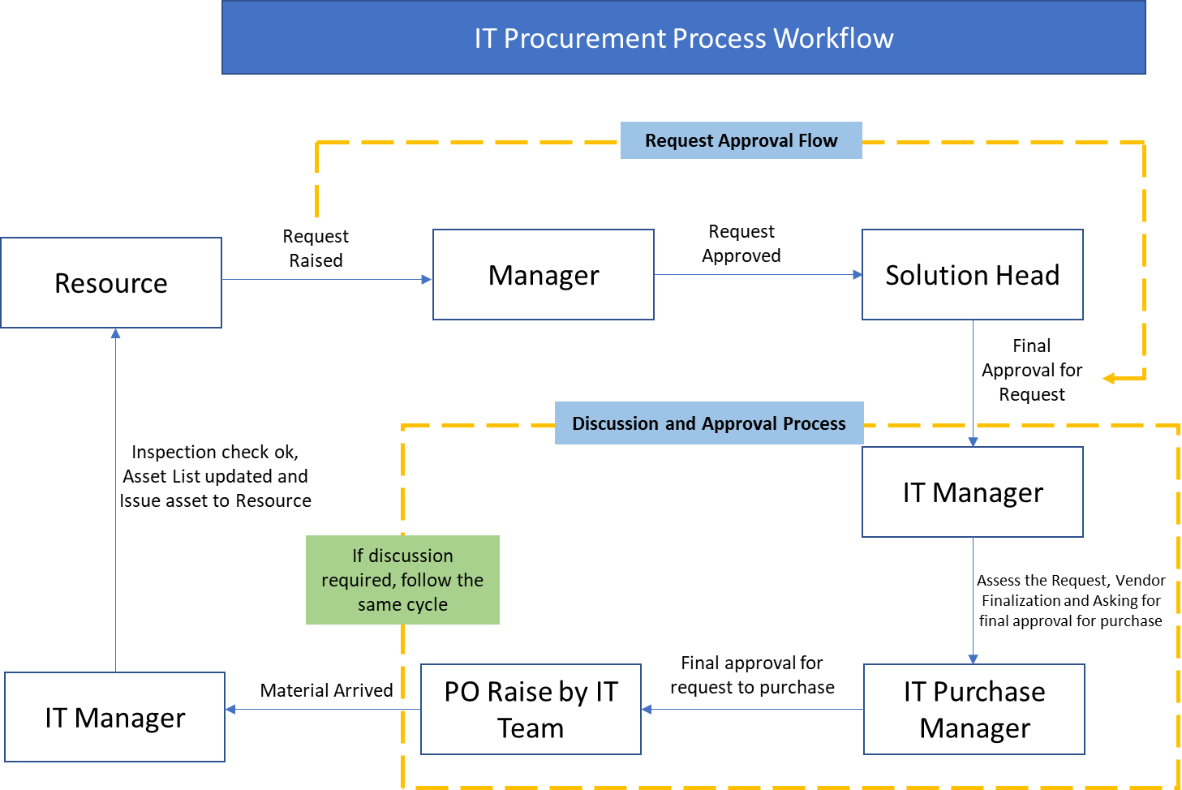

## Source Options

The business needs to determine where to obtain the product and services. The team should have an approved vendor list. If not, the team will need to search for a supplier using purchase orders or research a variety of other sources such as magazines, the Internet or sales representatives.

## Making Purchase

IT department is responsible to refer to respective Purchase Requirement for making the purchases. Deviation from purchase requirement may occur due to following reasons:

* Identify the need of item/product to be purchased.
* Make research for the different aspects of product.
* Purchase can be done Online or Offline.
  + Offline purchase
    - Ask different Vendors to price quotes with technical specifications. (If applicable)
    - After the quotes received, negotiates the best price with vendors for the final order.
  + Online Purchase
    - Products are compared on various websites for better pricing and delivery/service/warranty options.
    - Price and quantity are not bounded.
* A Purchase from other vendor than specified needs to be done due to some reasons.
  + Vendor is asking for more prices than earlier quoted.
  + Any changes in the Contract or any terms & Condition by the vendor or by NST.
* IT Manager is responsible to do the final negotiation of the price for IT product or services. However, Price is not the only criteria of making the purchase. IT Manager (ITM) charge is responsible to ensure that the quality of the product or services is not compromised.
* After all the details are received, and the price has been negotiated and approved by IT p Purchase Manager, IT department is responsible to generate the PO/ (In lieu of PO email confirmations can be used having the technical specifications of the item to be purchased. In few cases PO is not necessarily generated (Depends on the type of requirement).
* A purchase order must be issued for all transactions and must be quoted on the invoice except for consumable items like mouse, keyboard, LAN cable etc. When purchasing under an existing contract or vendor, the purchaser must quote the number (and lot number if applicable) and supplier code through SAP system on the purchase order. Purchase in-charge is responsible to make a draft for the requirements for in house requirements for products and services.
* IT manager can buy Online purchase and purchase directly through OEM.

## Purchase Status Update

* IT Team is responsible to update senior management regarding the status of the purchase as per the purchase requirement on monthly basis. Amendments if required are incorporated.
* If the approved vendors from the vendor list do not cater to the requirements, the IT department will seek quotations from non-approved vendor, at the time of making the purchase. (At least two quotes need to be taken in case purchases are made from non-approved vendor, if possible).
* While evaluating the vendor, CK-12-VEM-SW Vendor Evaluation Matrix should be used.
* In case of existing service agreement with the vendor, which needs to be renewed, the details of the same are mentioned.

## Tracking of Purchases

* IT Team is responsible to check the status of the purchase and any undue delays are brought to the notice of senior management and the indenter. The supplier processes are evaluated as appropriate by conducting demos, review of technical specs, periodic progress review meetings and performance analysis. In case of any delay/product non-conformity, valid details are requested from the vendor.
* On delivery of the material, the It Team or the person authorized can arrange for inspection with the user group if needed.
* The IT Team or the person authorized must check that the items delivered are as per the Purchase Order.
* The material is accepted if the inspection is found to be satisfactory & IT Team or the person authorized is responsible to sign off on the Challan (Where ever applicable, Free format, belongs to the vendor) as an acceptance of the material.
* If rejected the IT Team shall advice the vendor to take back the material or make necessary rectification for acceptance.
* On the acceptance of material by IT department, Challan, if applicable and invoice will be handed over to Accounts Dept for releasing the payment.
* Asset list will be maintaining on central repository. All other documents will be maintaining on shared folders accessible only to authorize person.
* The procurement Process will be audited as per audit plan and base on the Non-Compliance (NC) if any improvement finds then it will go to Process improvement log.

## Vendor development and performance evaluation

IT Team in coordination with IT Purchase Manager is responsible to evaluate the materials and services offered by approved & non-approved vendors on yearly basis. While short listing the vendors, or moving vendor from non-approved vendor status to the approved vendor status the Purchase in-charge may consider the aspects like:

* The client base of the vendors
* Whether the vendor is authorized dealer for that product/Services
* The vendors’ dependability and reliability based on market feedback
* The company's experience with the vendor
* Location
* References

While price competitiveness is one of the major criteria for selection of vendors, quality aspect of the supply should not be sacrificed. Therefore, the lowest price in the quotation need not be the sole criteria in the short-listing process.

Service-wise Vendor List would be maintained for quick reference. However, a vendor not performing up to the expected level will be removed from this. Under following cases, a vendor can be removed:

* Non delivery of committed product/services
* Serious misconduct with person dealing

# Output

* Purchase order raised from SAP system/ Email
* Software License report
* Updated Asset List

# Validation

* Review of purchase requirements by senior management
* Inspection of the purchase by the IT team
* Review of Licence/services

# Exit Criteria

* Purchase order
* Challan
* Inspection report

# Reference documents

* Challan (Vendor format) / Invoice

# Glossary

* PO – Purchase Order
* TAT – Turn Around Time
* NC - Non-Compliance
* ITM- IT Manager